**Press Release**

**MultiSMART International Conference on Multi-Component Soft Materials**

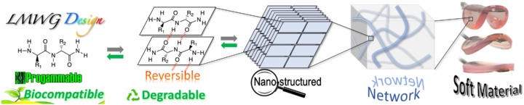

March 25–27, 2026 | Institute of Physical Chemistry, University of Stuttgart, Germany

The MultiSMART International Conference on Multi-Component Soft Materials will convene leading experts from academia and industry to explore the latest advancements in the design, formulation, and application of innovative soft materials. This interdisciplinary event aims to bridge the gap between fundamental research and real-world applications, fostering collaboration across chemistry, biology, physics, and engineering.

Organized by the MultiSMART Doctoral Network, a Horizon Europe-funded initiative, the conference will feature keynote addresses from distinguished scientists:

* **Prof. Dr. Nathalie Katsonis** (University of Groningen, Netherlands) – Renowned for her work on bio-inspired molecular systems and adaptive materials.
* **Prof. Dr. Lihi Adler-Abramovich** (Tel Aviv University, Israel) – Expert in self-assembling peptides and their applications in nanotechnology.
* **Prof. Dr. Meital Reches** (Hebrew University of Jerusalem, Israel) – Specializes in peptide-based nanostructures and their role in materials science.
* **Prof. Dr. Patricia Dankers** (Eindhoven University of Technology, Netherlands) – Focuses on functional biomaterials for tissue engineering and regenerative medicine.
* **Prof. Dr. Rein V. Ulijn** (Advanced Science Research Center, CUNY, USA) – Known for his research on bio-inspired nanomaterials and their applications.
* **Prof. Dr. Job Boekhoven** (Technical University of Munich, Germany) – Investigates dynamic materials and their potential in synthetic biology.
* **Dr. Niki Baccile** (Sorbonne Université/CNRS, France) – Specializes in the design of soft materials with tailored properties.
* **Dr. Arjan Gelissen** (Sasol, Germany) – Expert in the development of sustainable surfactants and emulsifiers.
* **Dr. Jochen Kleinen** (Evonik, Germany) – Focuses on the application of functional materials in industrial processes.

The conference will cover a range of topics, including:

* Design and synthesis of multi-component soft materials.
* Advanced formulation techniques for industrial applications.
* Integration of soft materials in personal care, cosmetics, and home care products.
* Emerging applications in tissue engineering and regenerative medicine.

This event provides a unique opportunity for researchers, industry professionals, and students to engage with leading experts, share knowledge, and explore collaborative opportunities in the field of soft materials science.

For more information and registration details, please visit the [official conference website](https://www.ipc.uni-stuttgart.de/MultiSMART-conference/).

[Registration NOW OPEN](https://eveeno.com/263686532)

[Abstract Submission](https://www.ipc.uni-stuttgart.de/MultiSMART-conference/Abstract-Submission/)

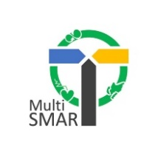

This work has received funding from the European Union's Marie Skłodowska-Curie Actions (MSCA) Doctoral Networks (DN) HORIZON-MSCA-2021-DN-01 under the grant agreement N°101072585, and was carried out within the network MultiSMART, funded as aforementioned and by the UKRI (grant agreement N° EP/X029980/1 and EP/X02895X/1).